Wiki Link:
https://github.com/WyattMorgan20/GDP-Group-1-Balance---AI-Assisted-Bookkeeping/wiki/Data-Management-Plan-(Iteration-2)

Important Data
- Data priority lies in robust data retention and auditability
- Names
- Timestamps
- Contact info
  - Phone numbers
  - Email address
- Receipts
  - Client-side: Keep screenshots
  - System-side: Extracted OCR/PDF format from screenshots for easier data collection
  - Digitized audit trails

ER Diagrams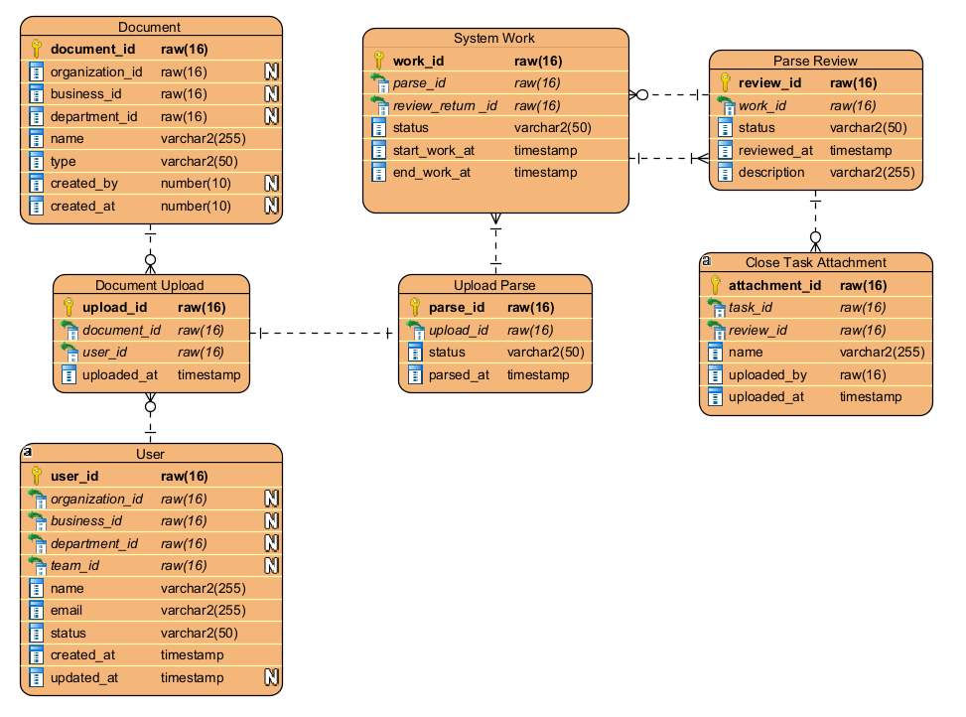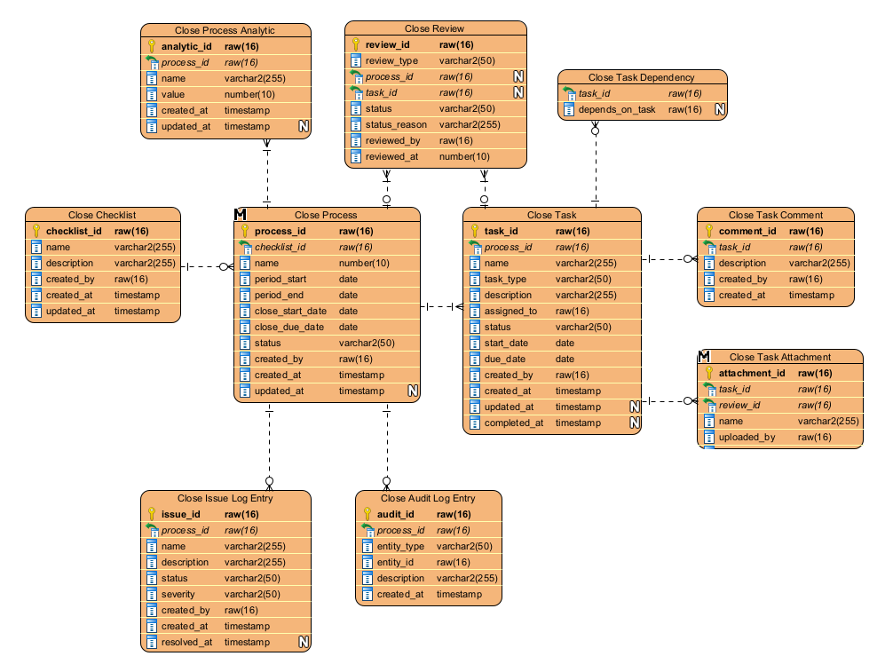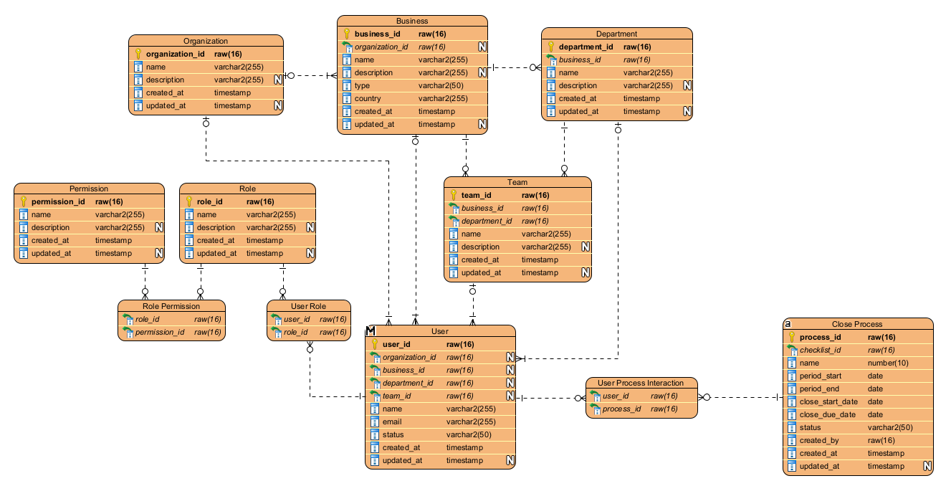

Data Security
- Data stored domestically
  - Prevents complexity of storing overseas/foreign
- Data deletion
  - Prevent deletion to preserve audit trails
  - Multi-factor deletion
  - Robust data retention - prevent accidental deletion, malicious deletion, etc.

Functional Requirements Mapping
Data will be shared and stored in a manner that corresponds to a user's permission level (admin, IT, etc.). The integrated AI may also have some form of permissions so that it can work with the data that is input and extracted, making the process more automated.

